# Computer network Chapter1

Outline :

How an application uses the Internet

The structure of the Internet:The 4 layer model

The Internet protocol (IP）： What it is

Basic architectural ideas and principles

* Packet switching
* Layering
* Encapsulation

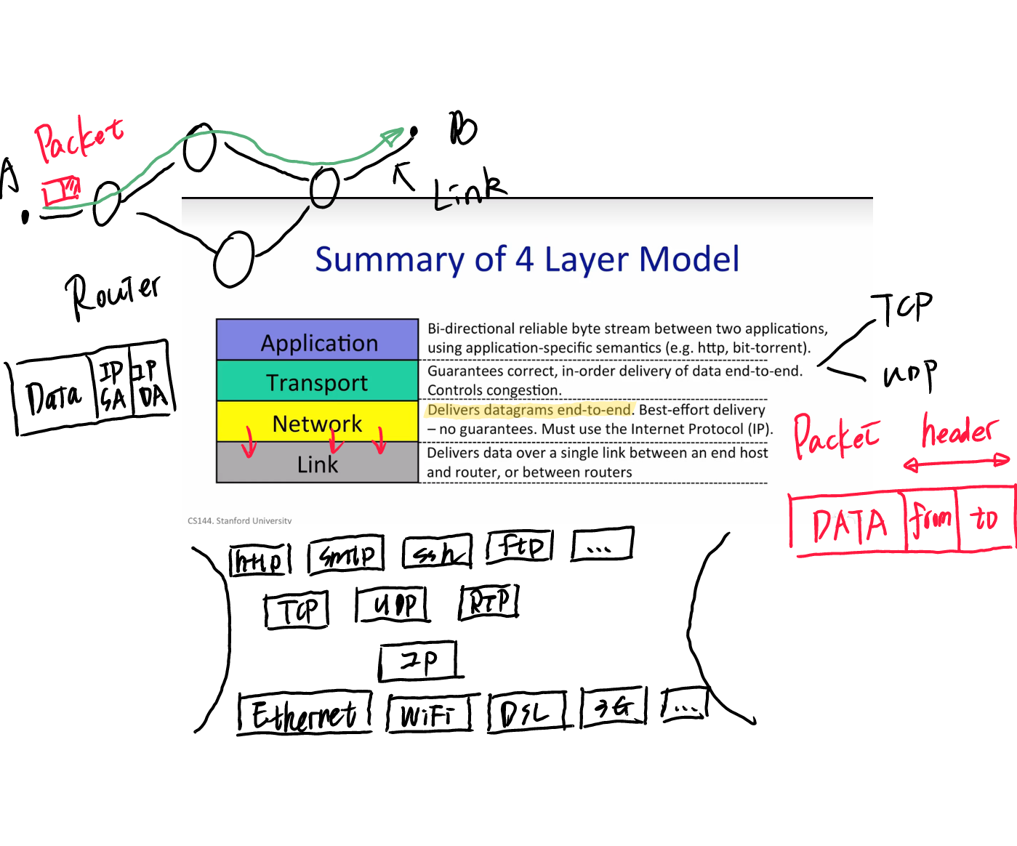

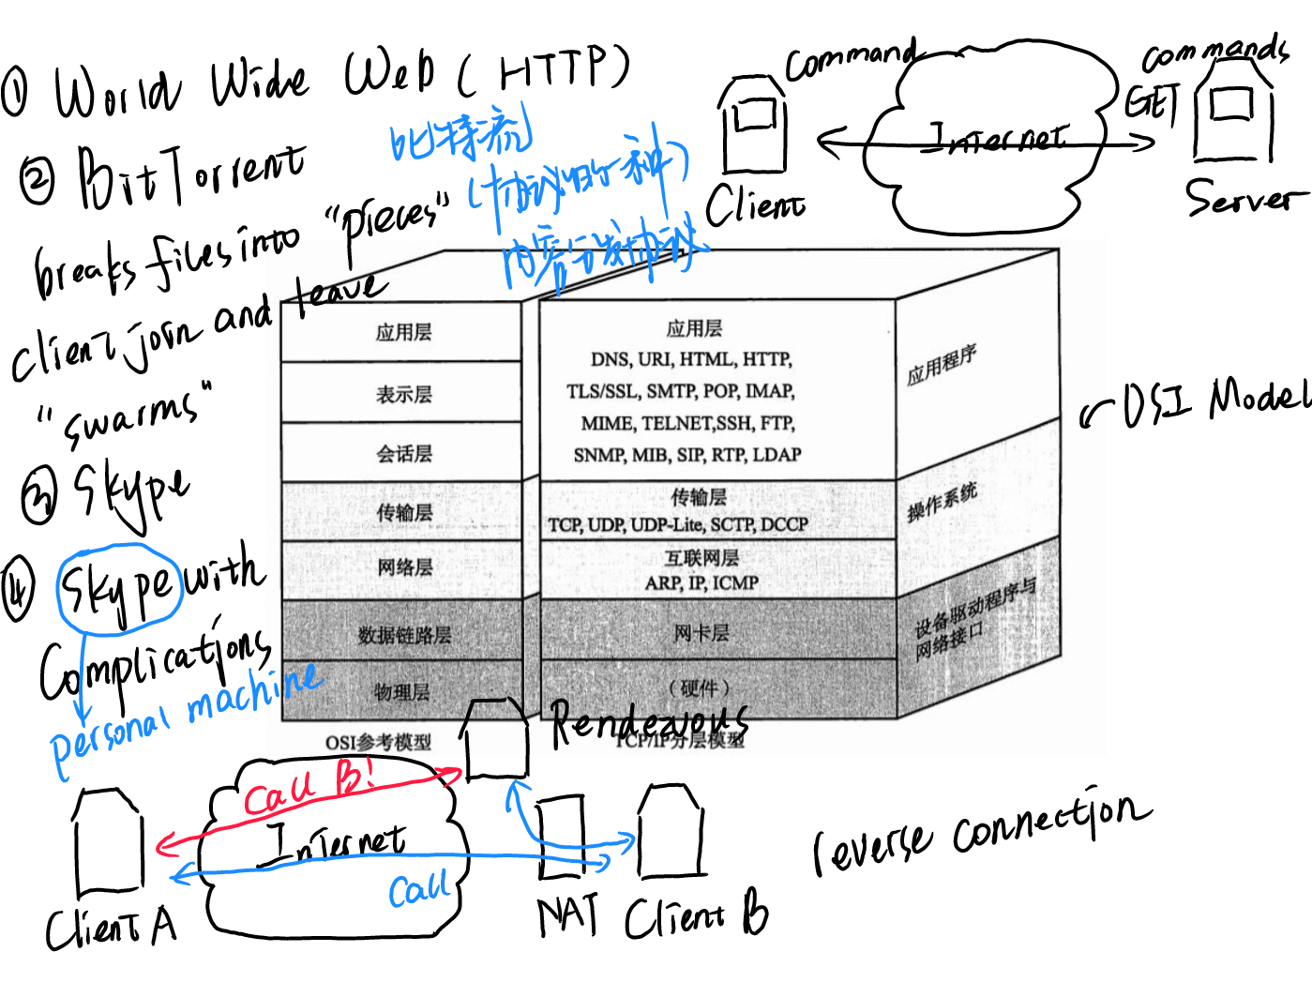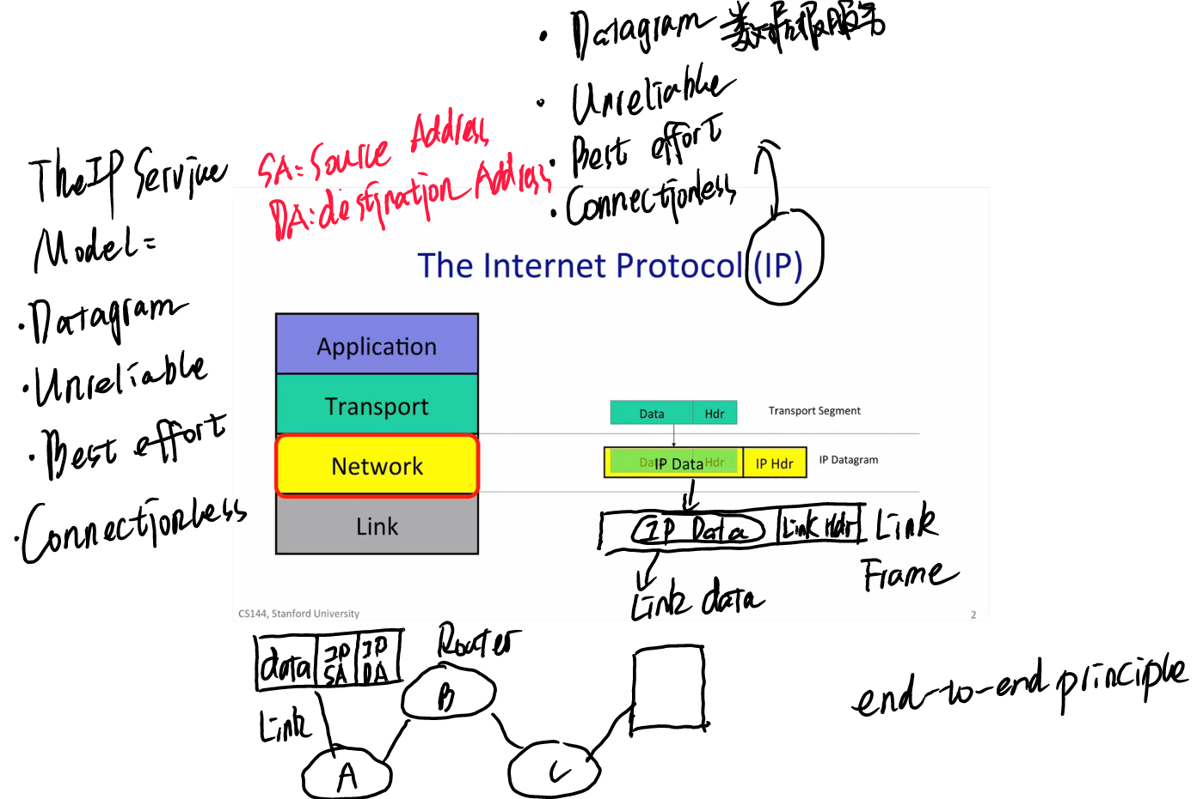

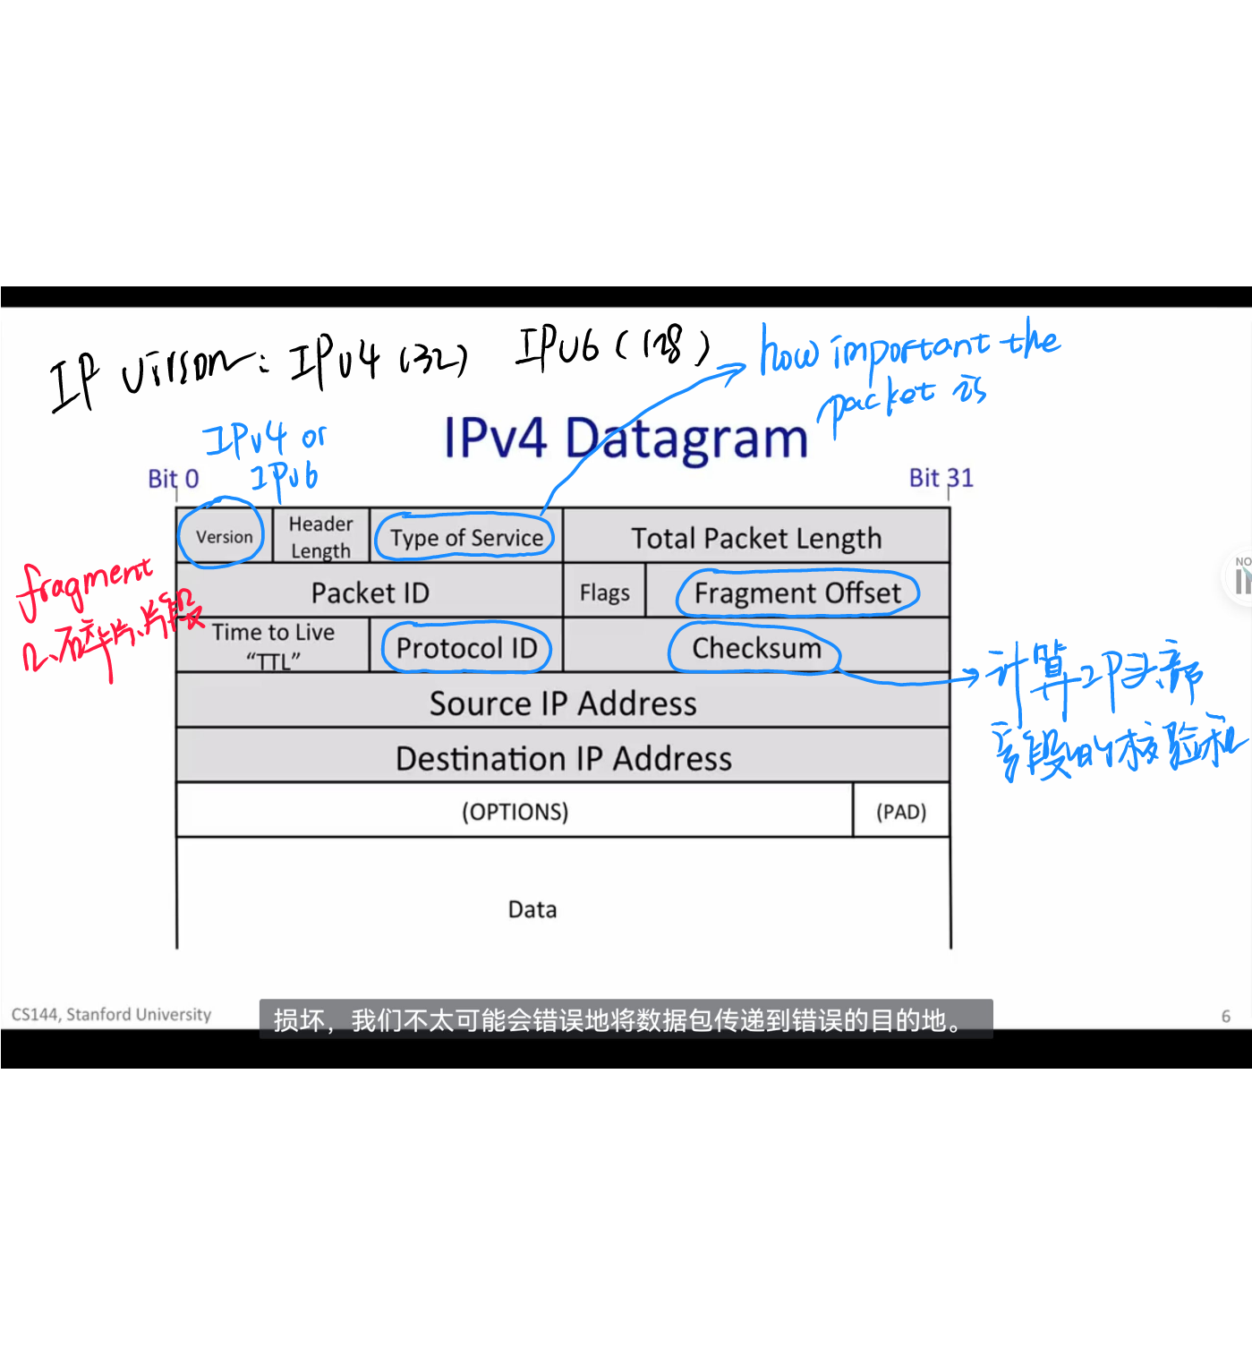

Packet:A self-contained unit Of data that carries information necessary for it to reach its destination

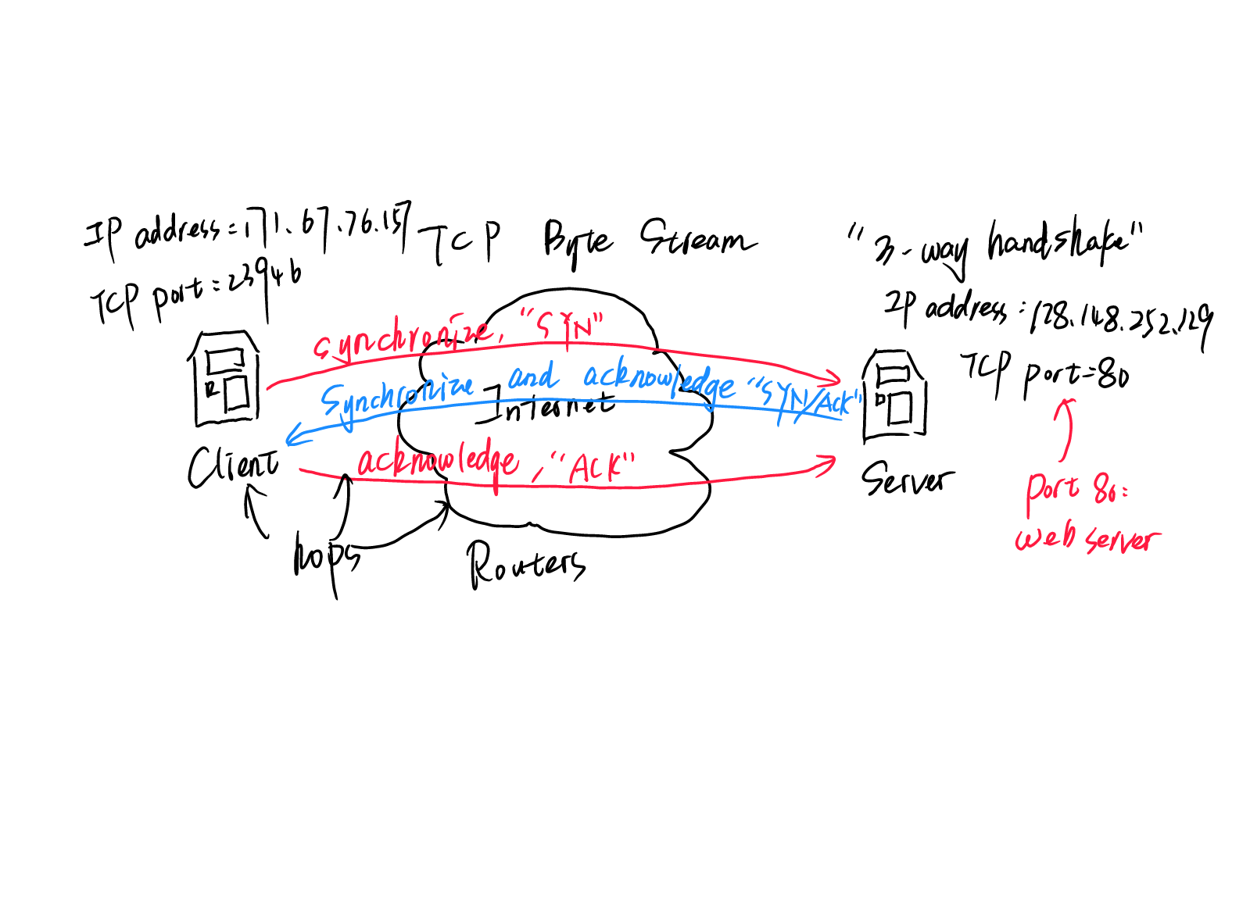

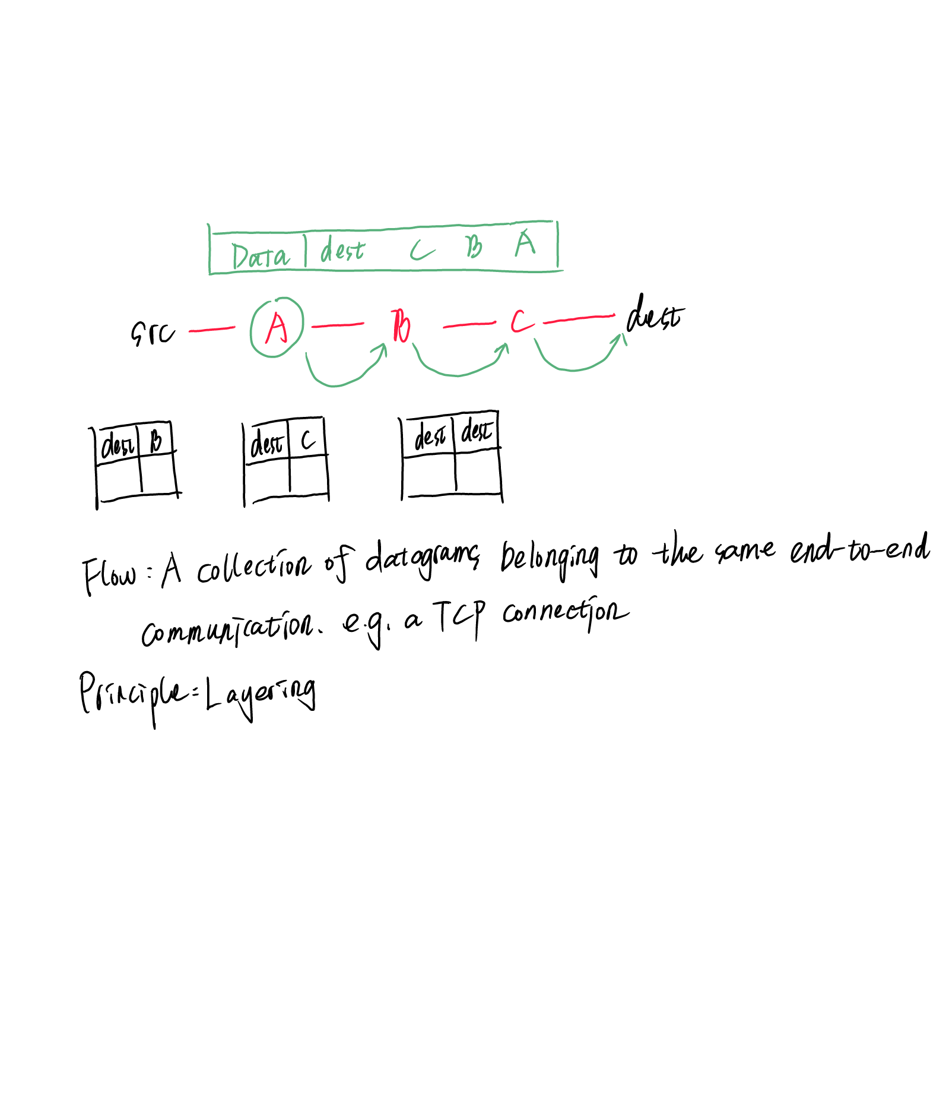

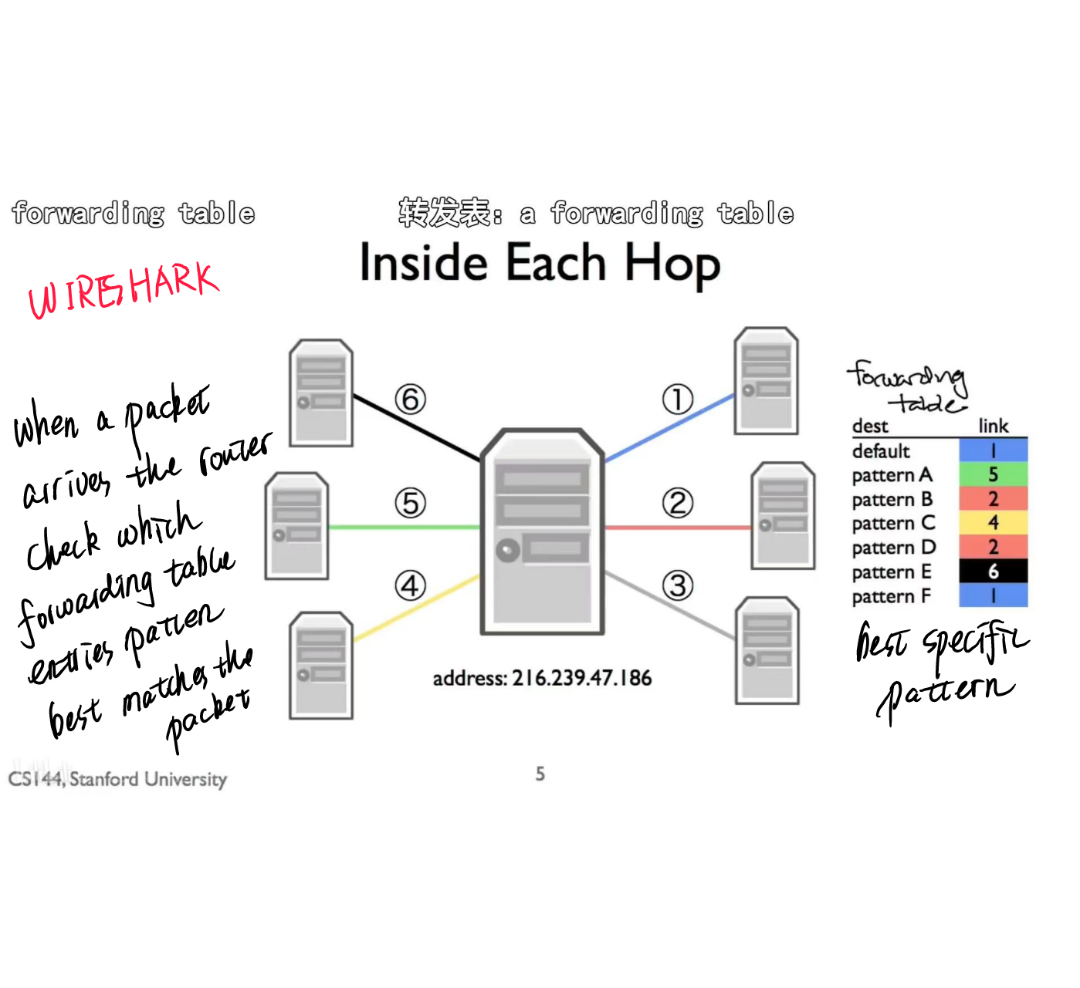

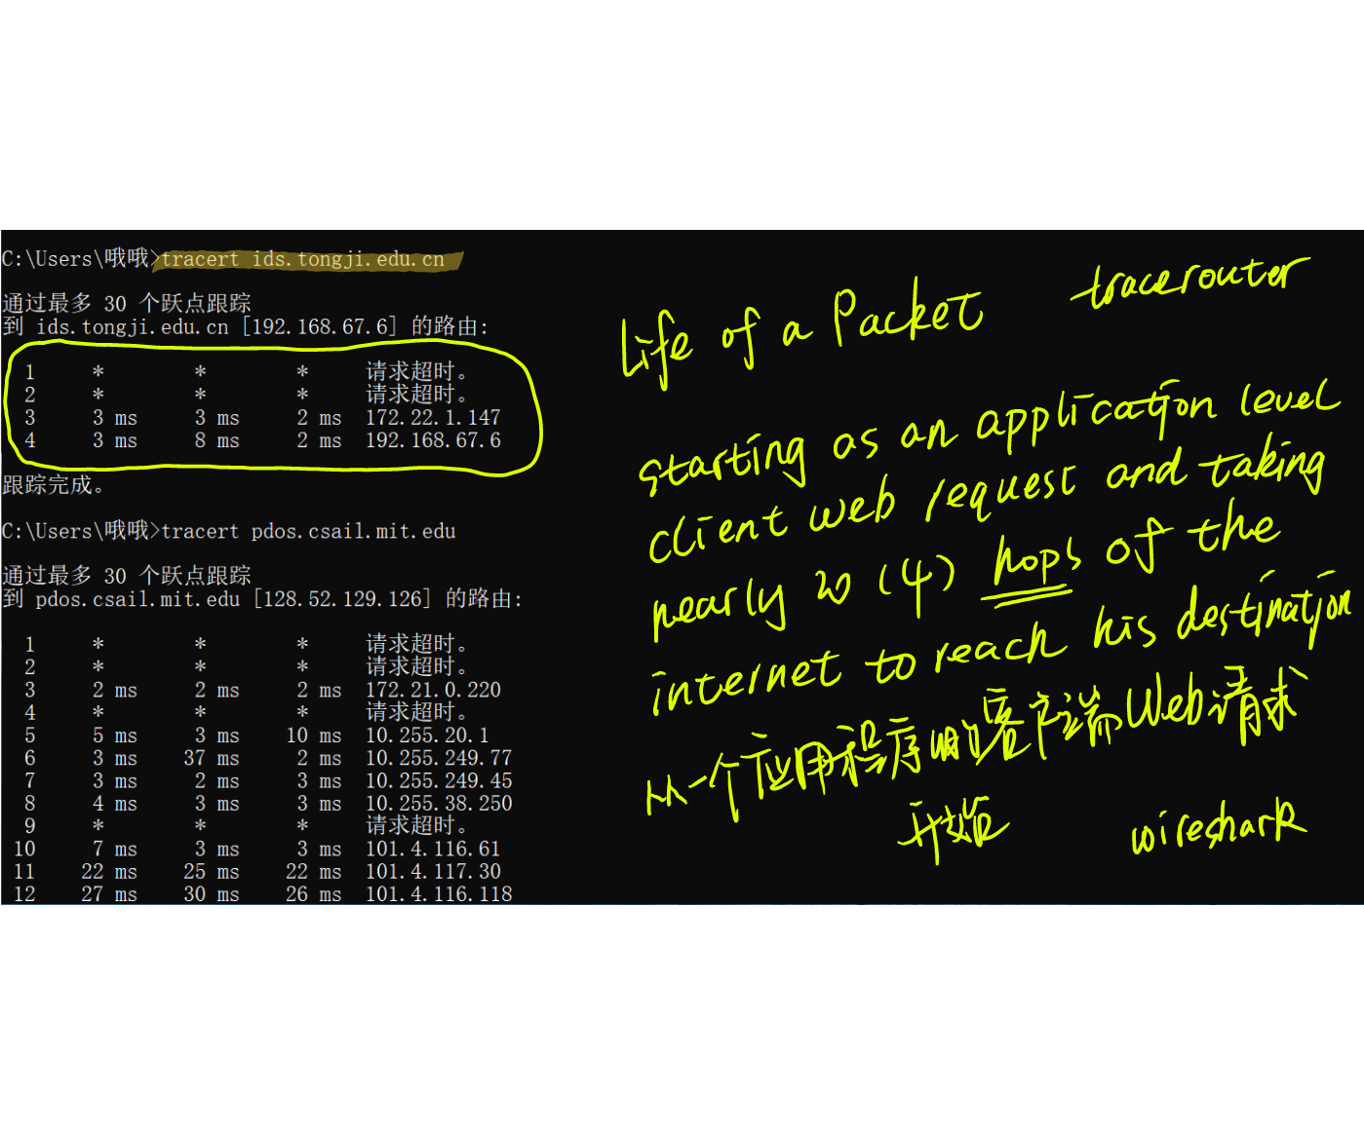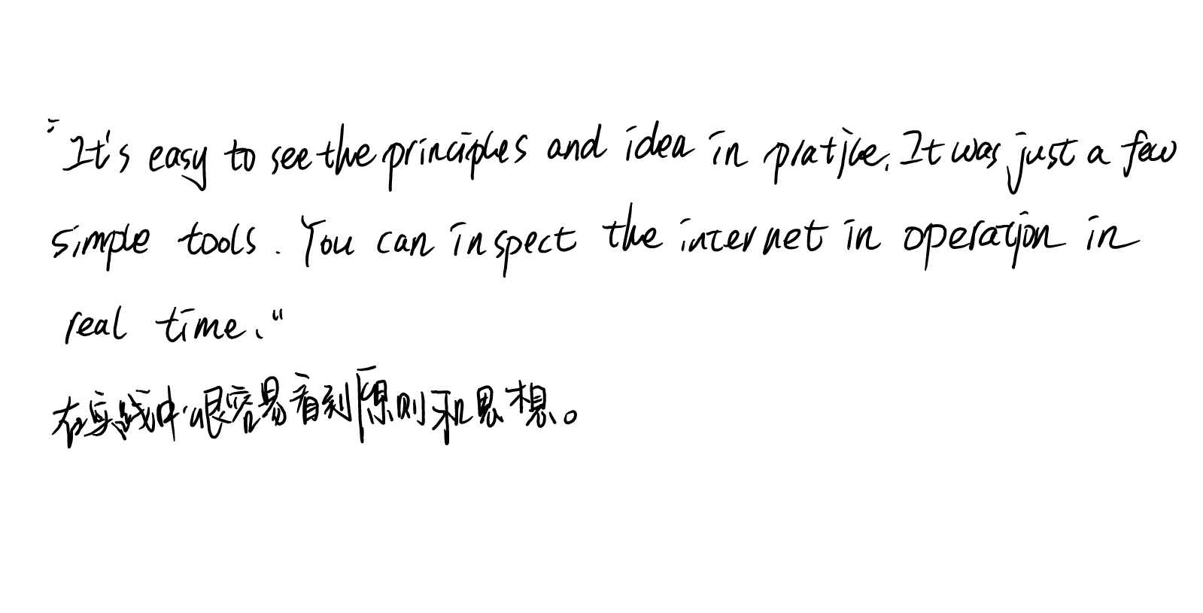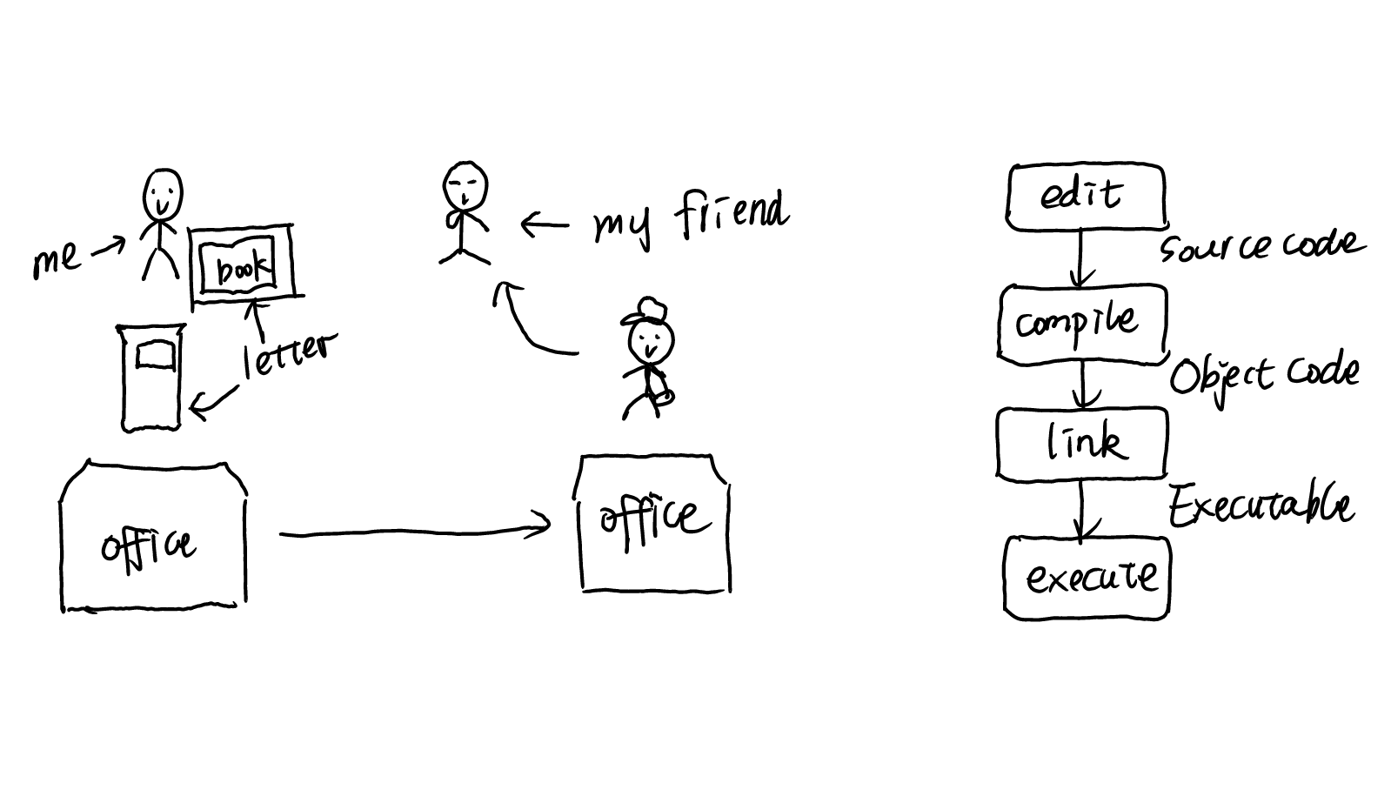

## 1.5 Principle: Packet Switching

## 1.6 Principle:Layering

分层是我们给系统组织成多个独立功能的名称、组件或图层

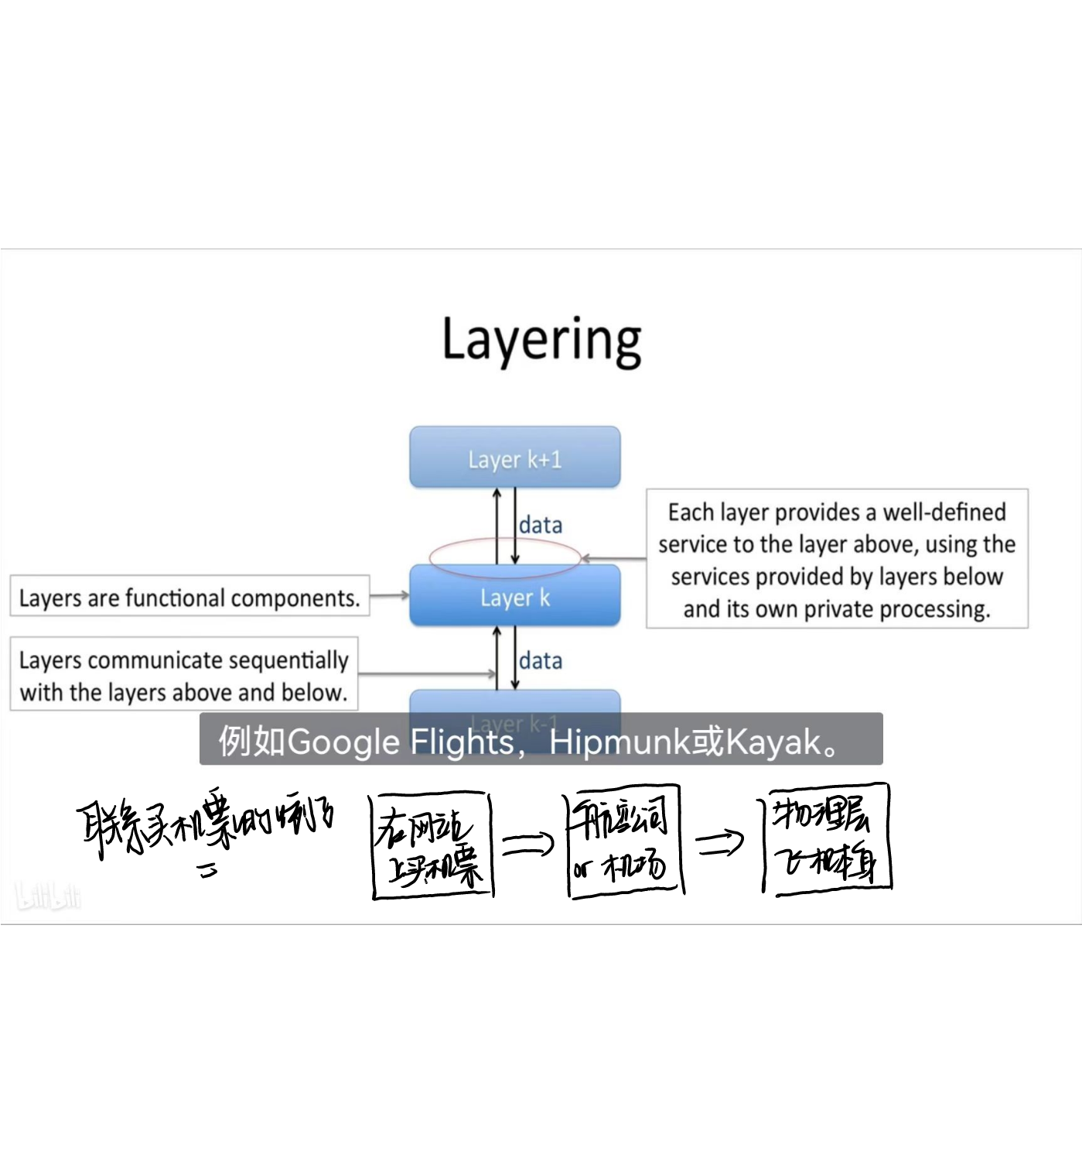Layering in a computer system

Reason for layering

1. Modularity
2. Well defined service
3. Reuse
4. Separation of concerns
5. Continuous improvement
6. Peer-to-peer communication

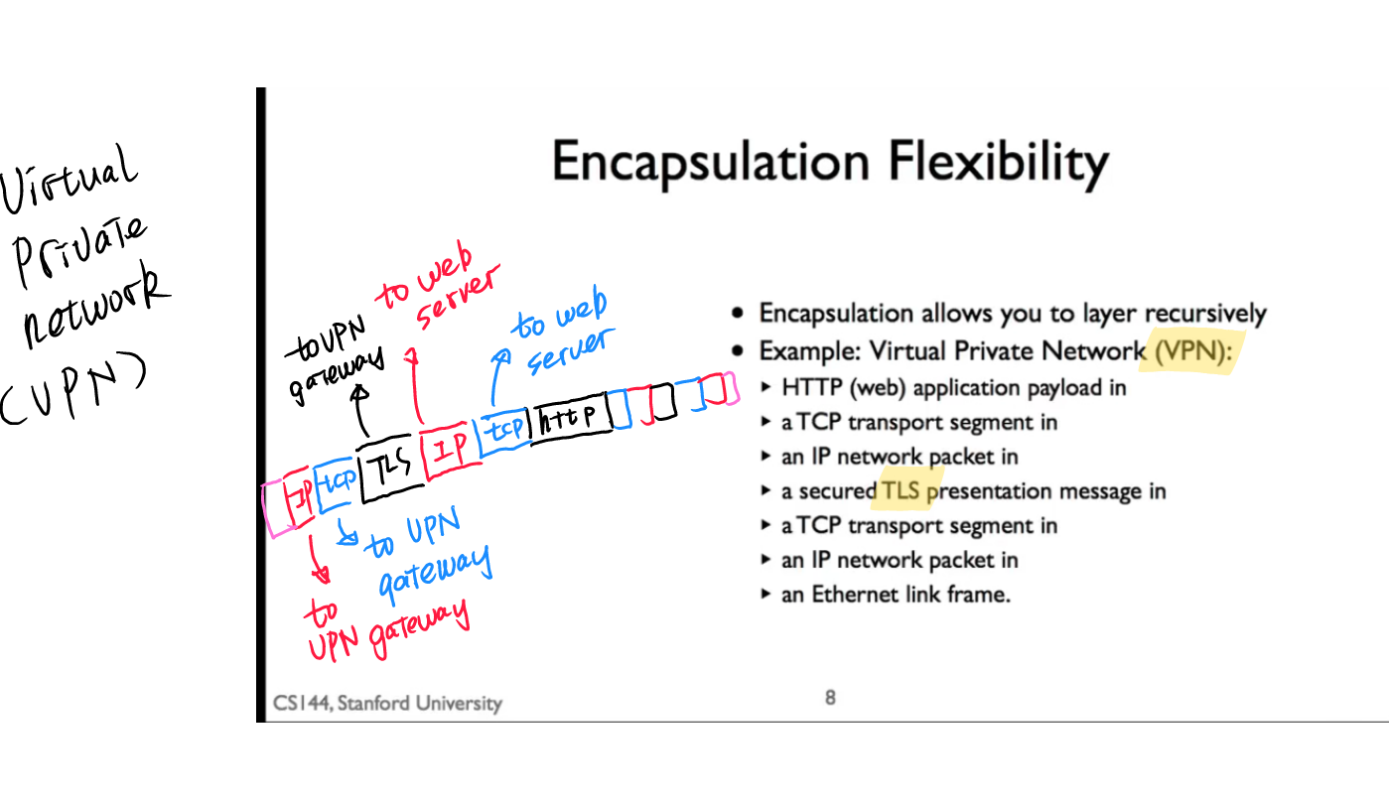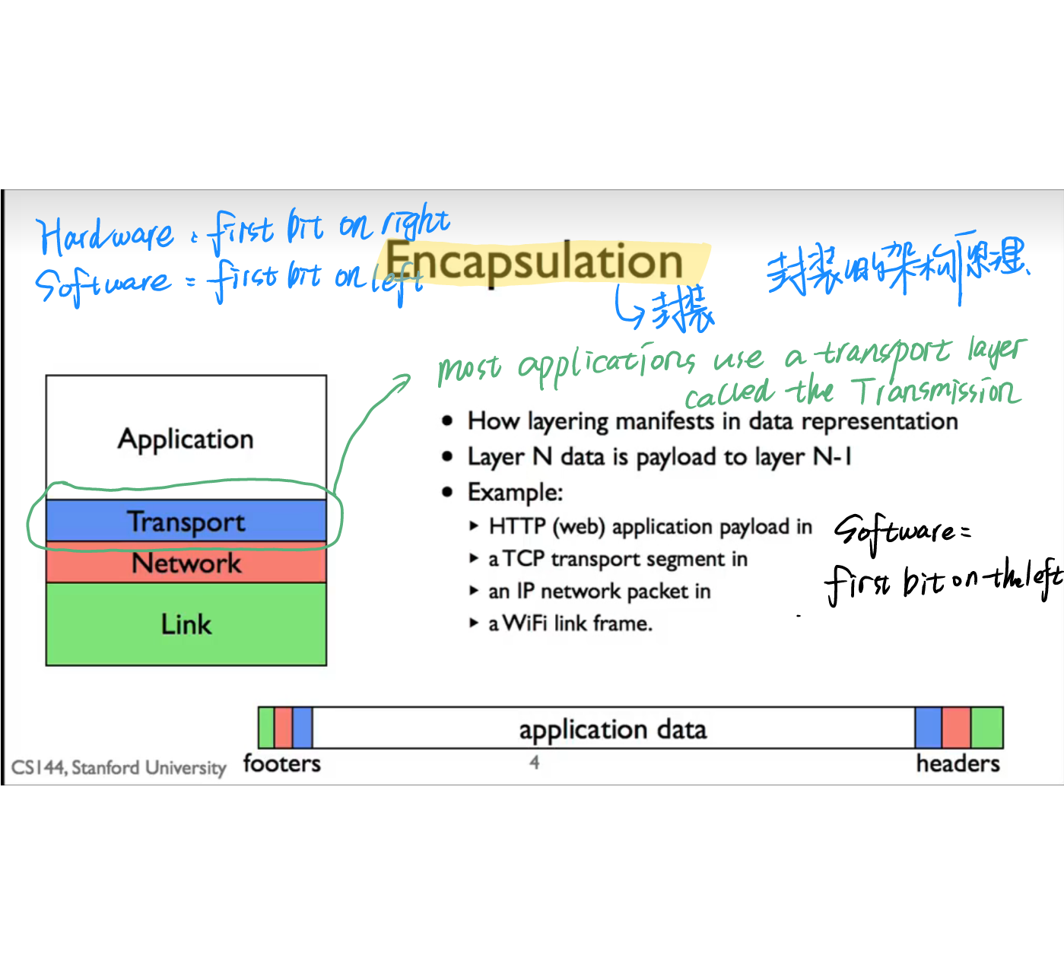This IP packet in turn encapsulating the top segment and the http get

Encapsulation is the result of what happens when you combine layers and packet switching.  
（组合层/数据包交换)

Encapsulation is the principle that lets us the protocol layers and let them easily share the storage within a package

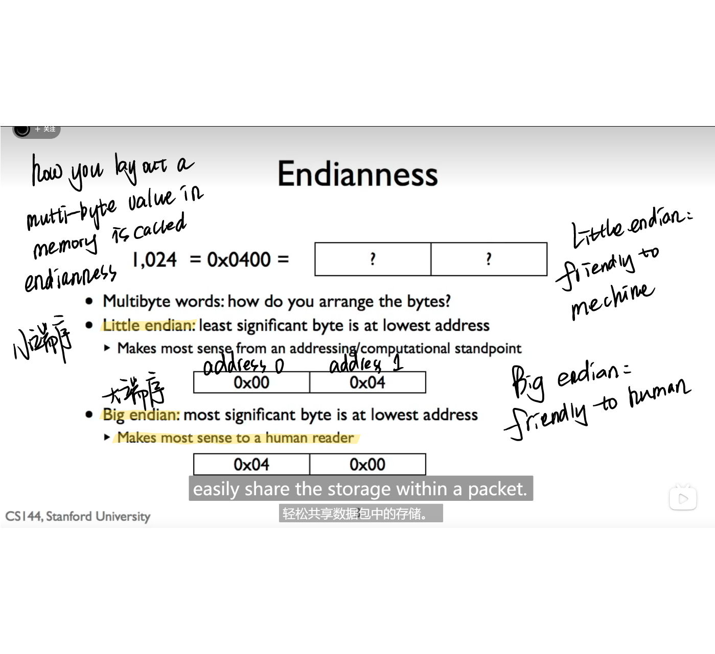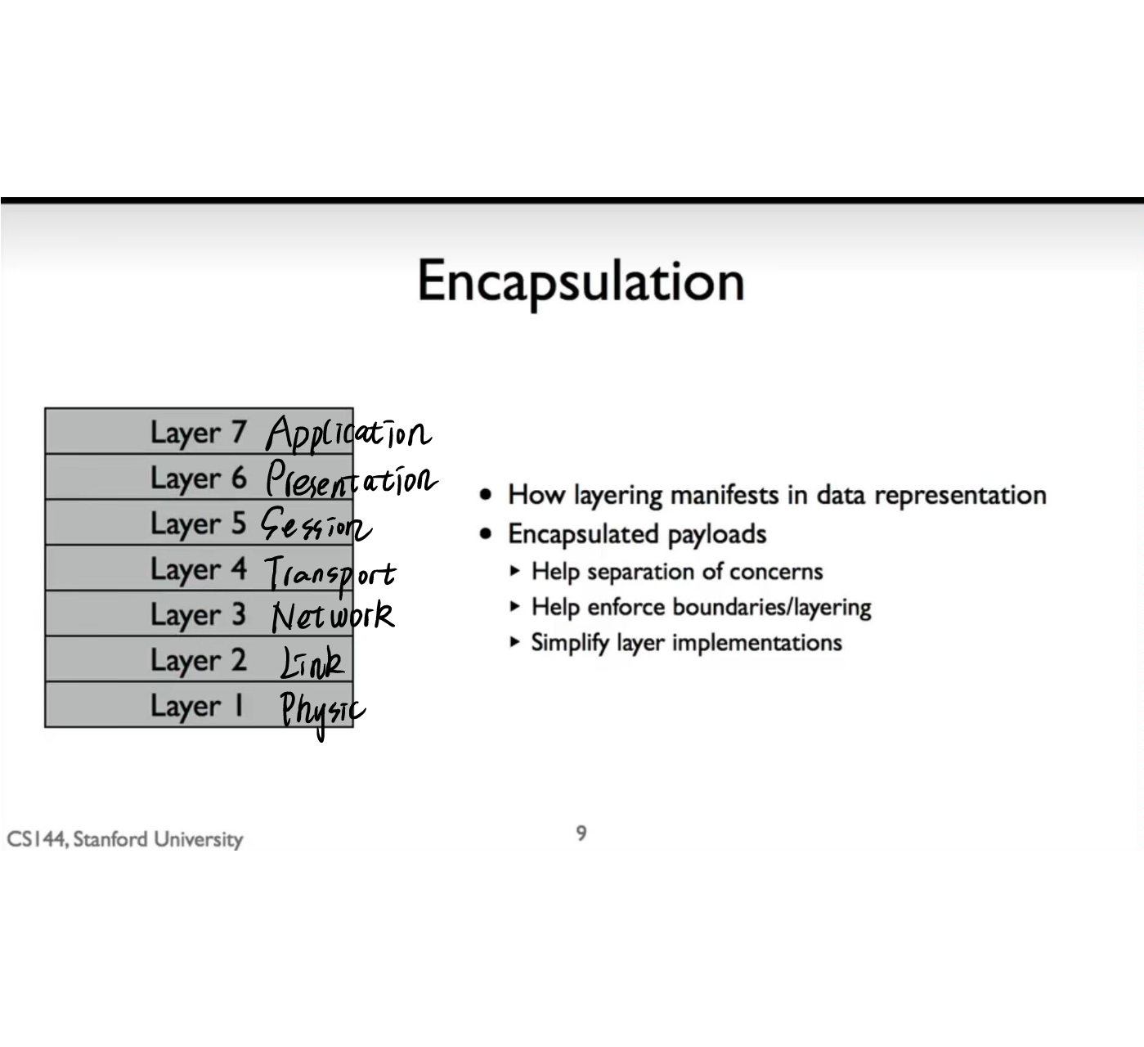封装是使我们能够接受协议层并让他们进行操作的原理

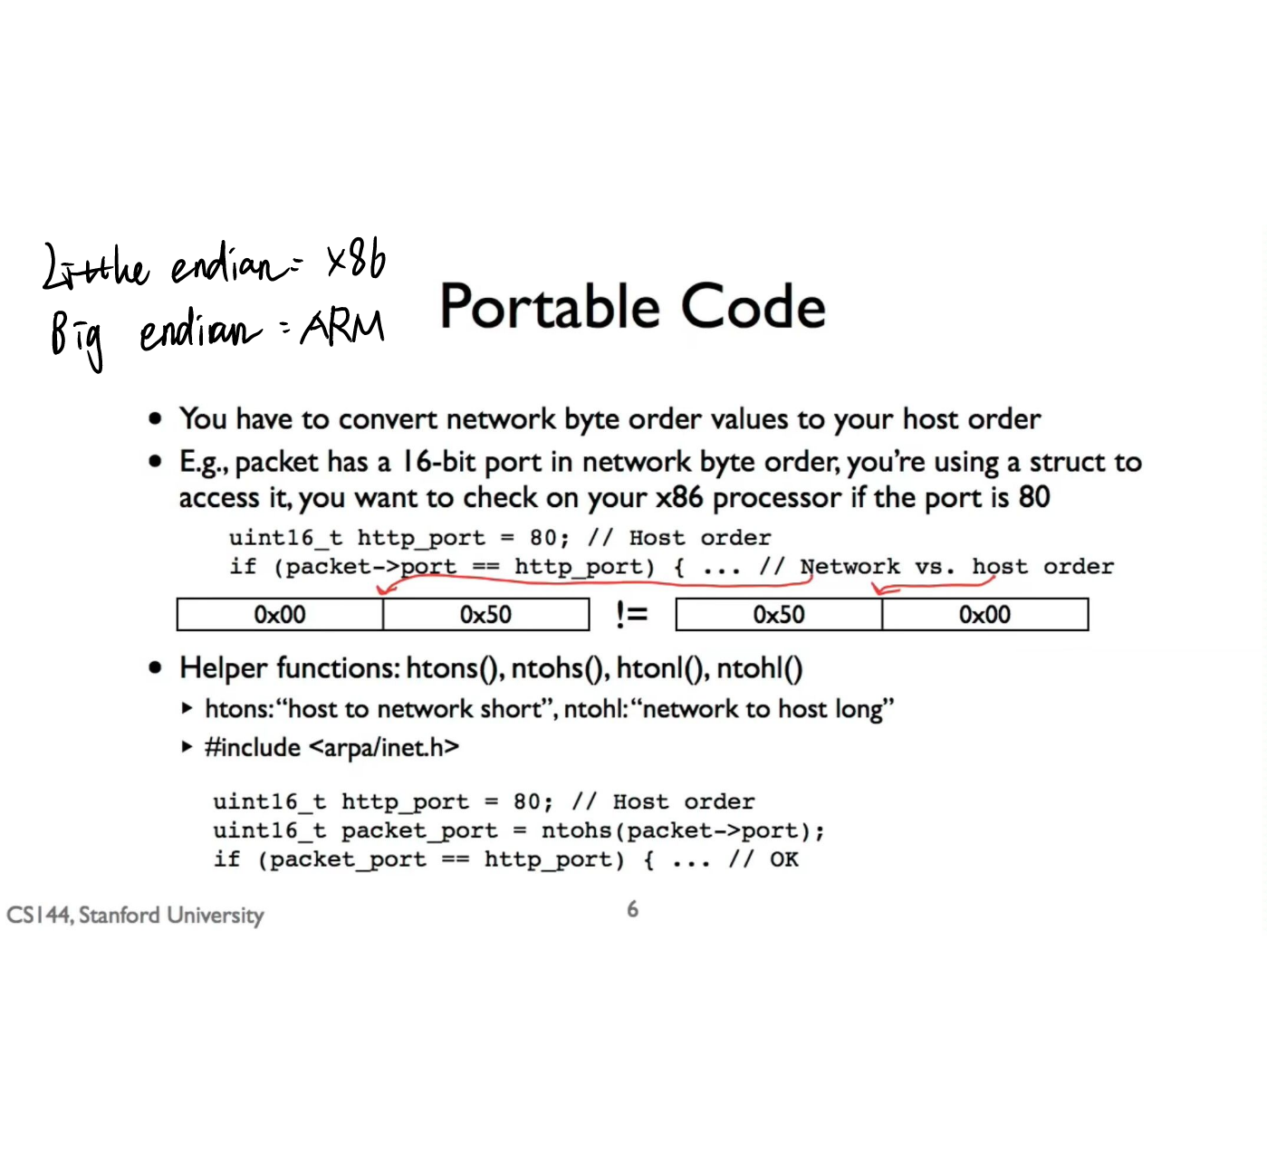

## 1.9 IPv4 addresses

An IPv4 address identifies a device on the Internet

## p9 1 8a Memory, Byte Order, and Packet Formats

format/format In、总体安排计划、设计

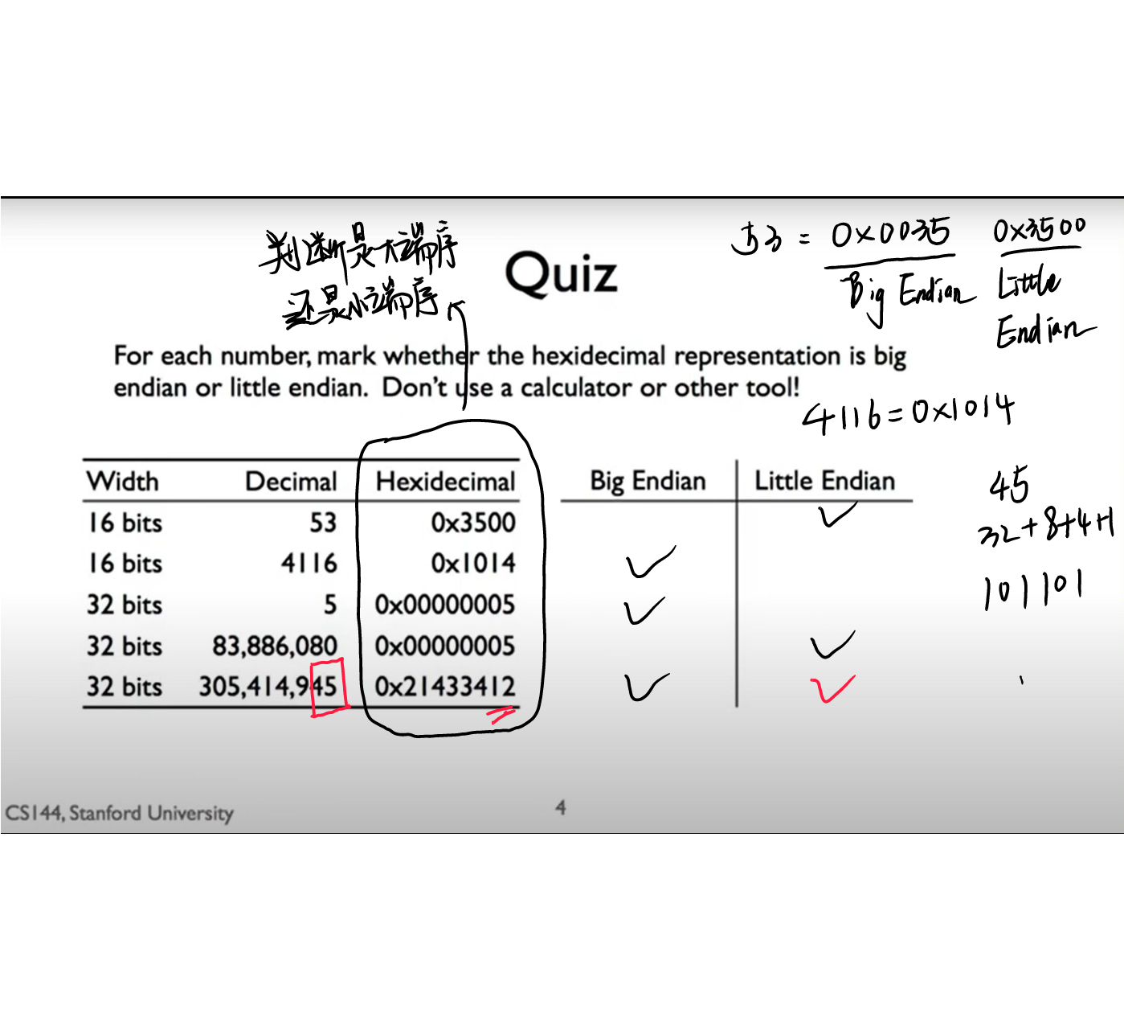

字节序补充：

守节序（端序尾序）. Endian

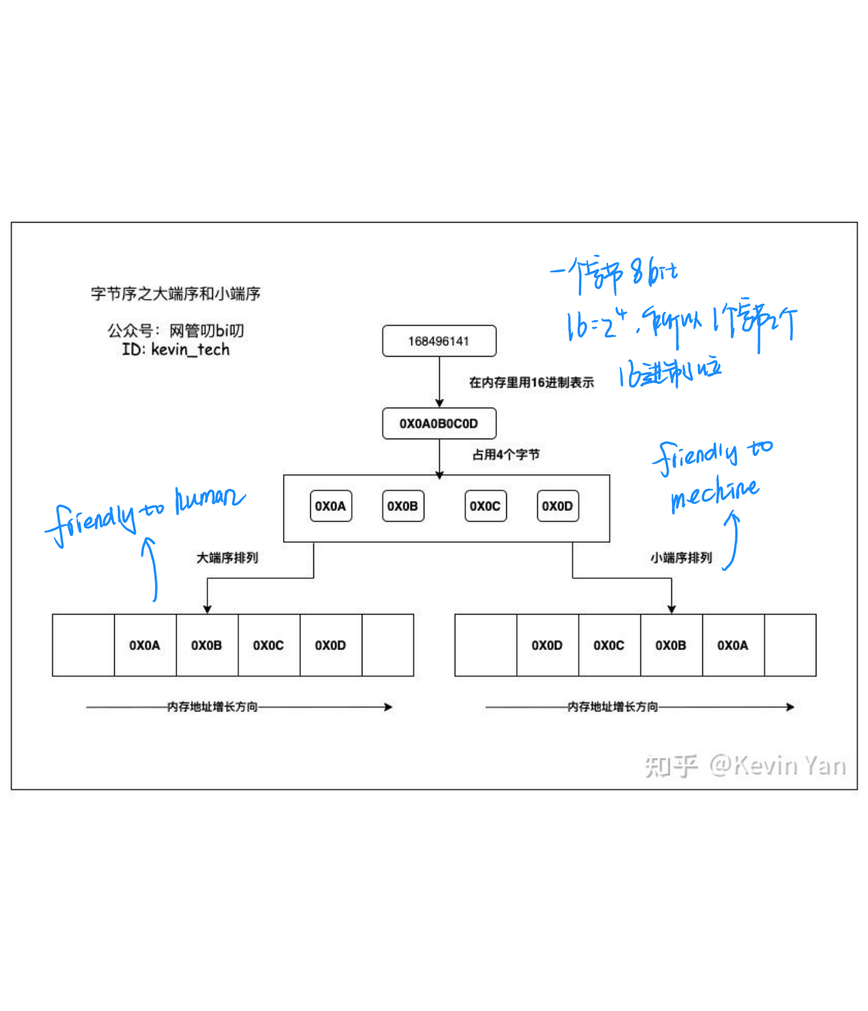在机算机领域中，指电脑内存中或在数字通信链路中，占用多个字节的数据的字节 排列顺序

子网掩码（网给掩码）：一种用来指明一个IP地扯的哪些位标识的是主机所在旧勺 网络地址，以及哪些位标识的是主机地址的㕸掩码

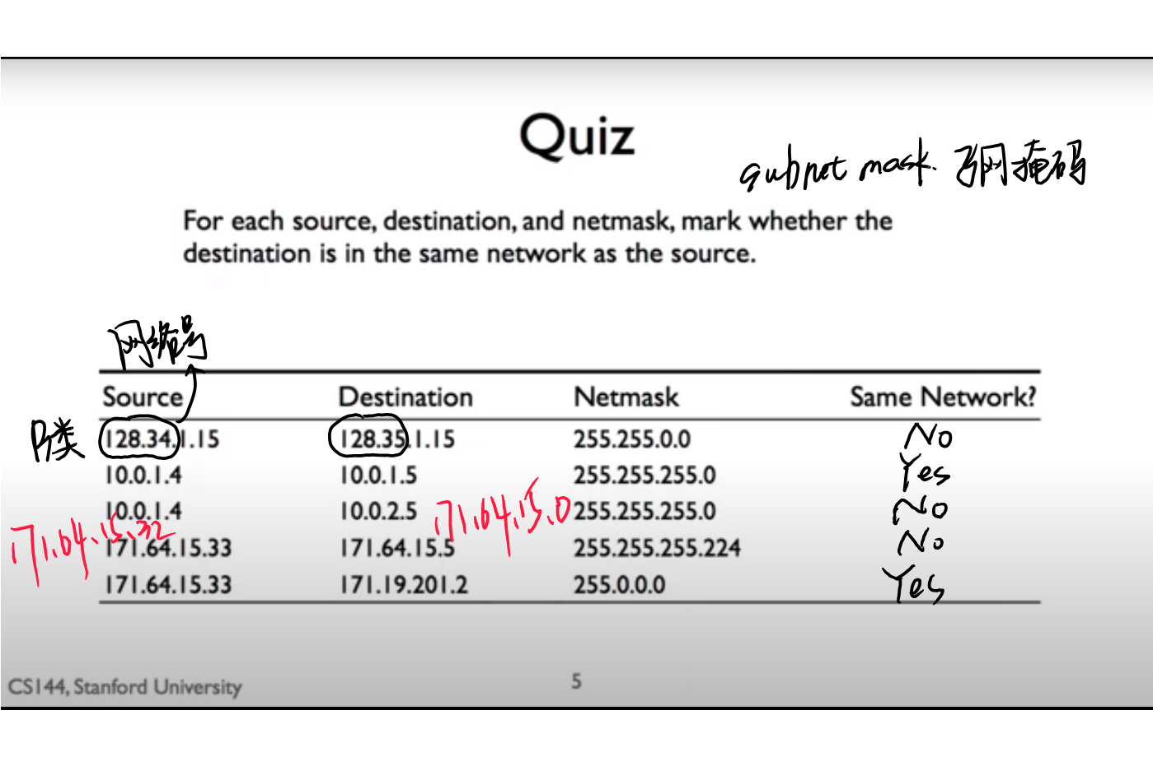

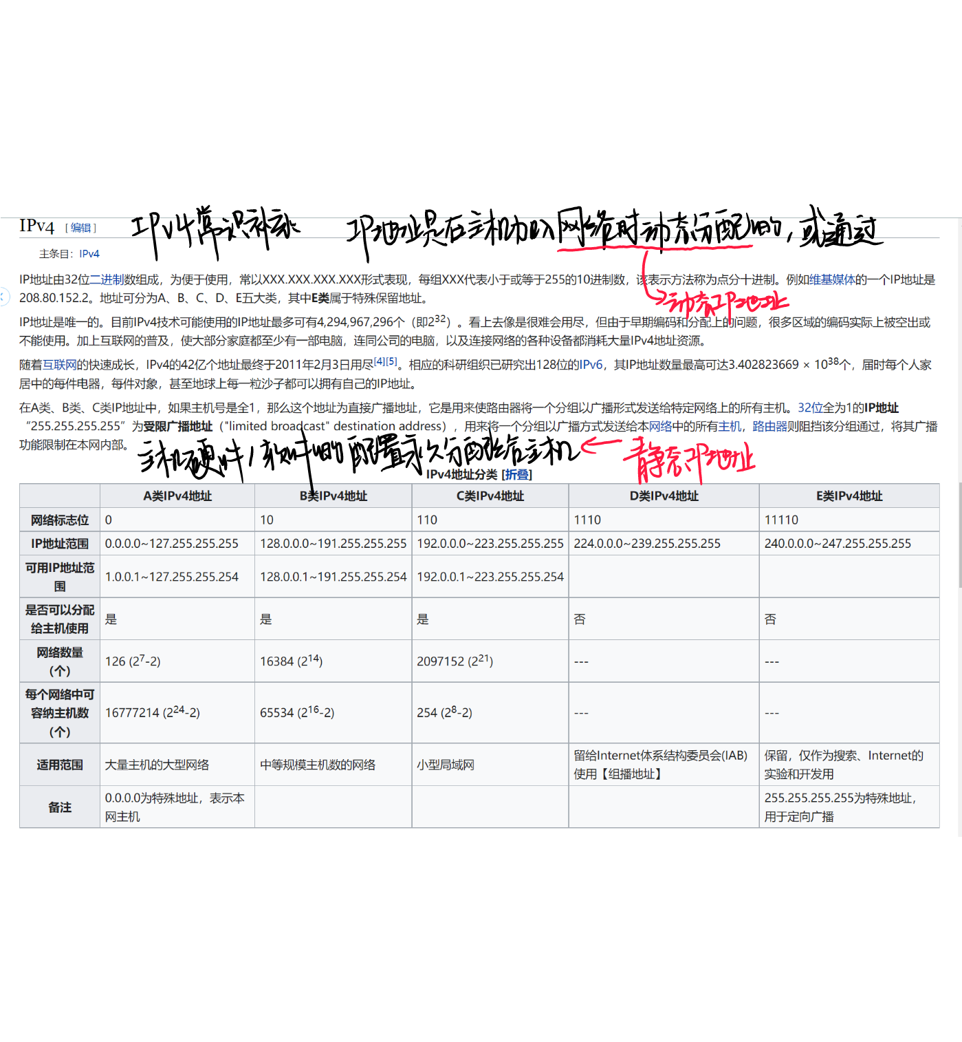

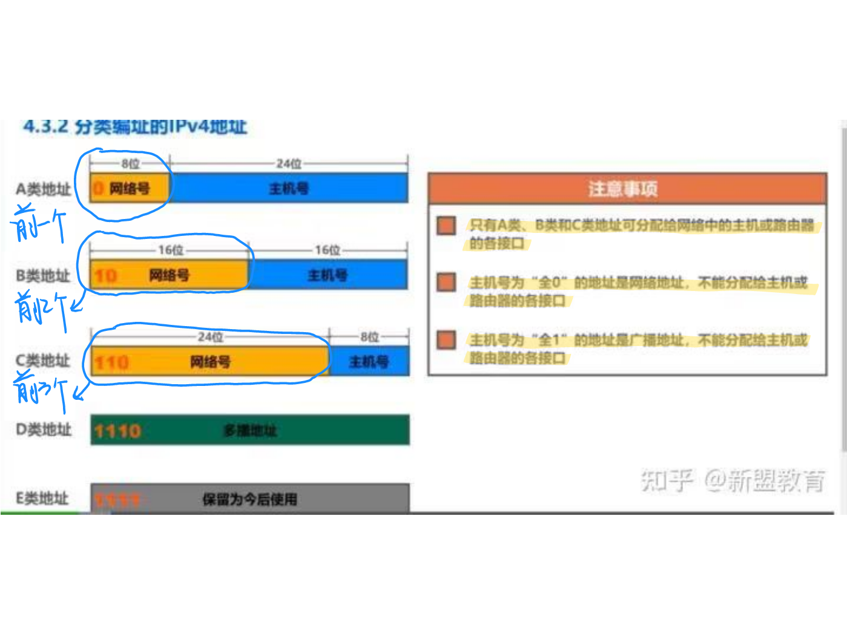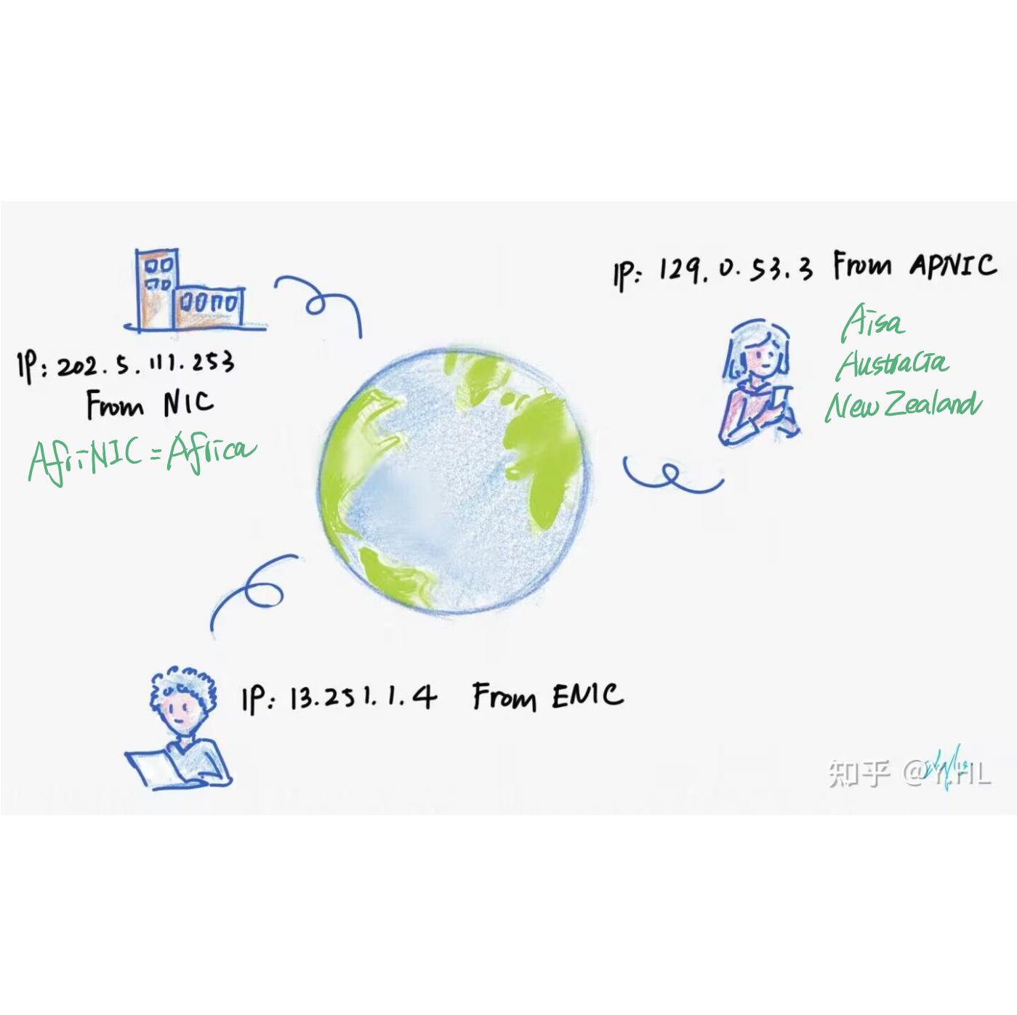

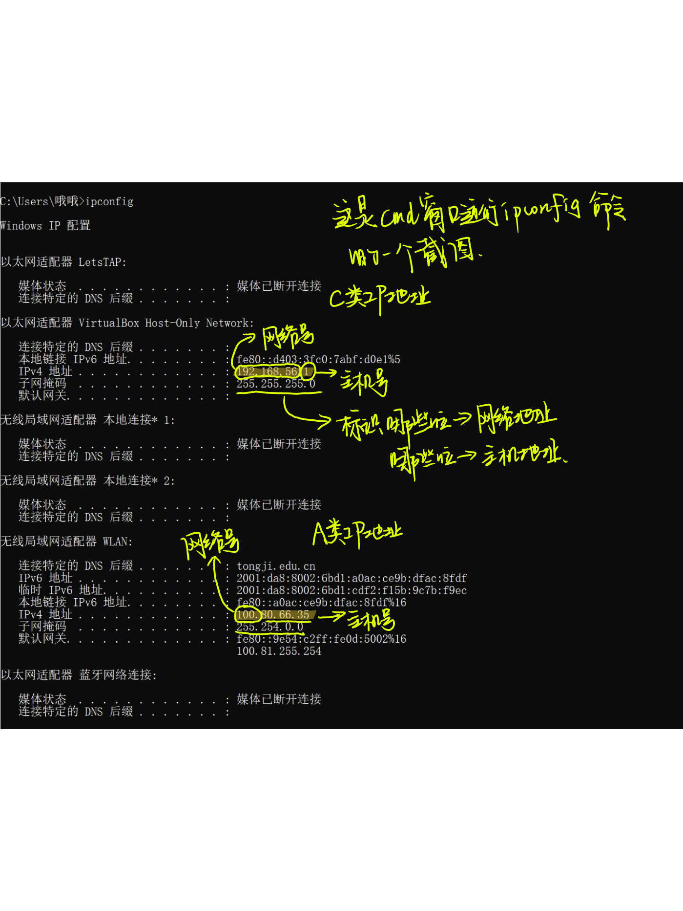

## Longest Prefix Match

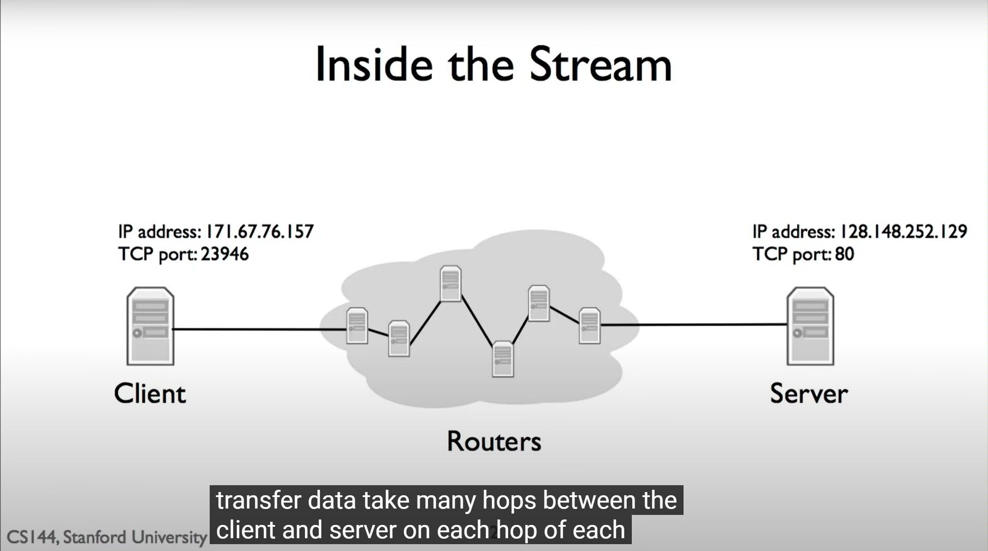

<https://blog.csdn.net/weixin_43275631/article/details/109960686>

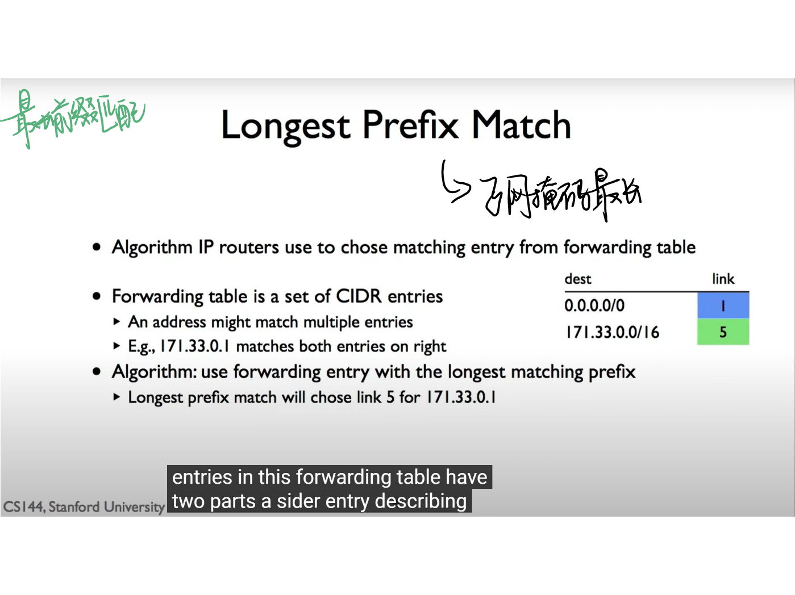

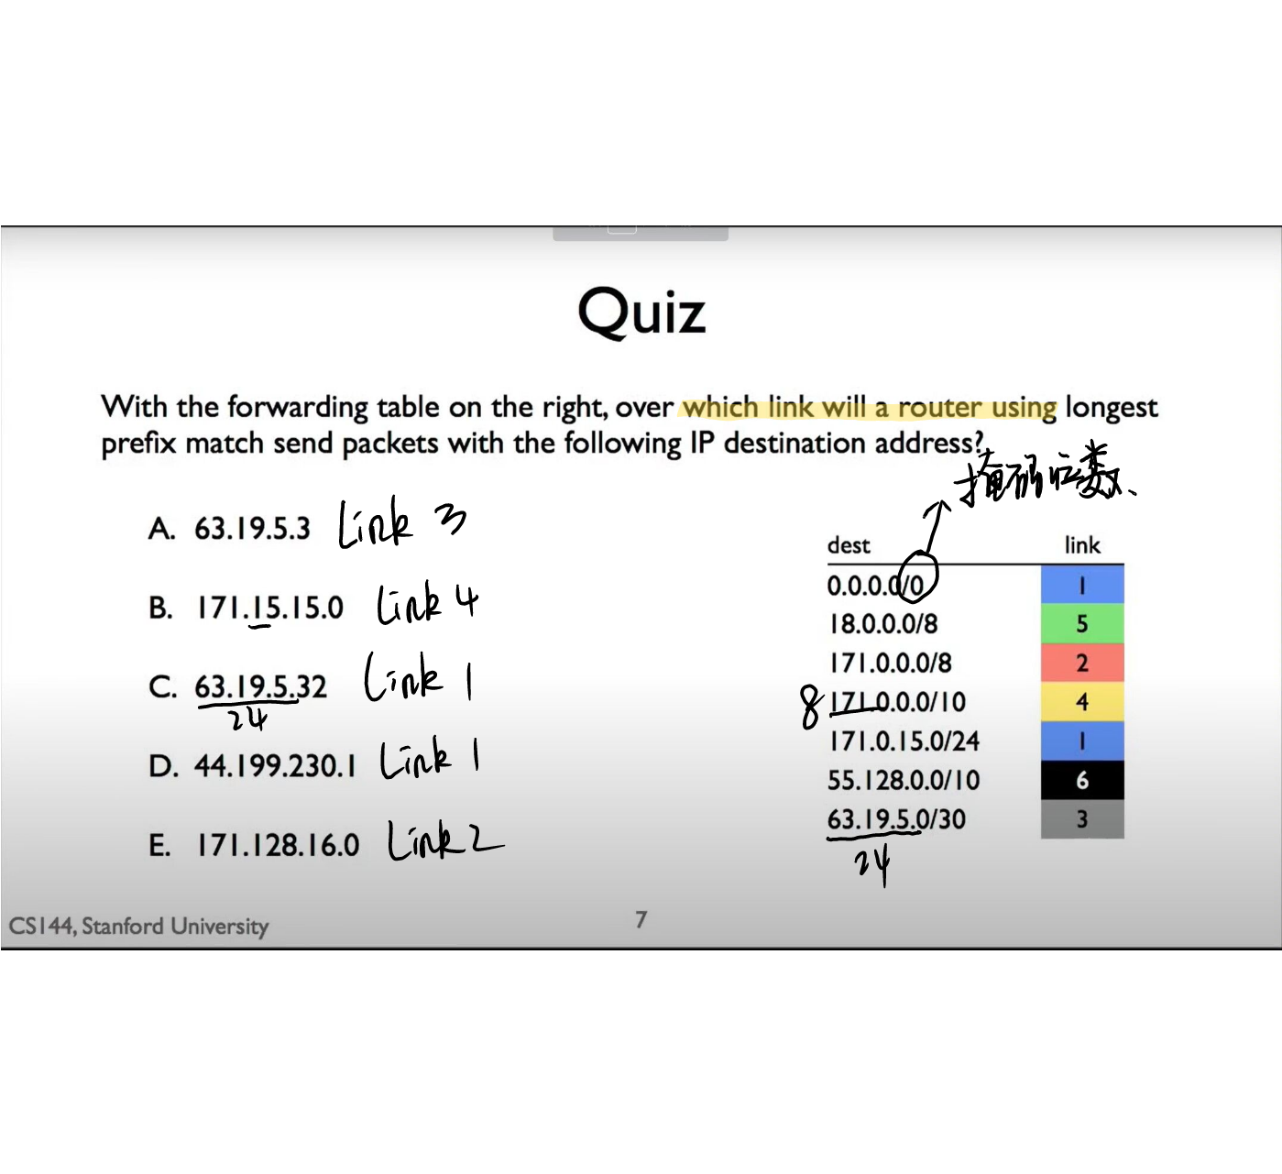

## Address Resolution Protocol (ARP)

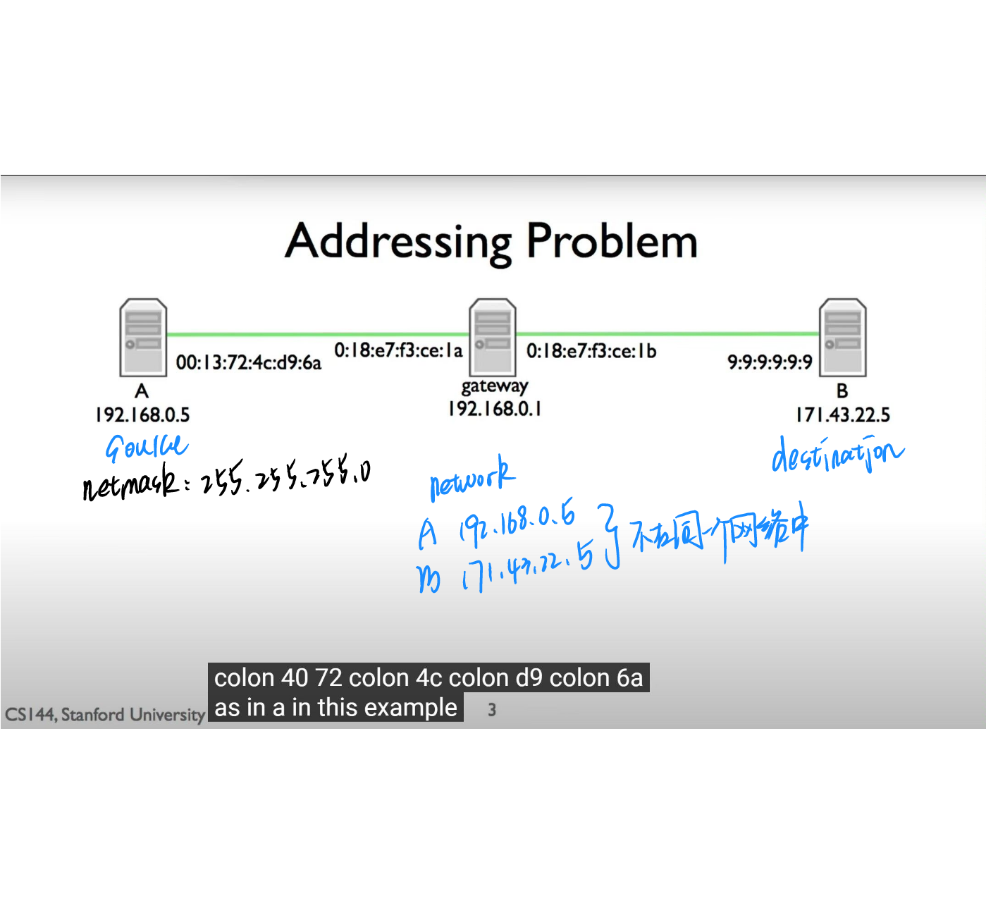

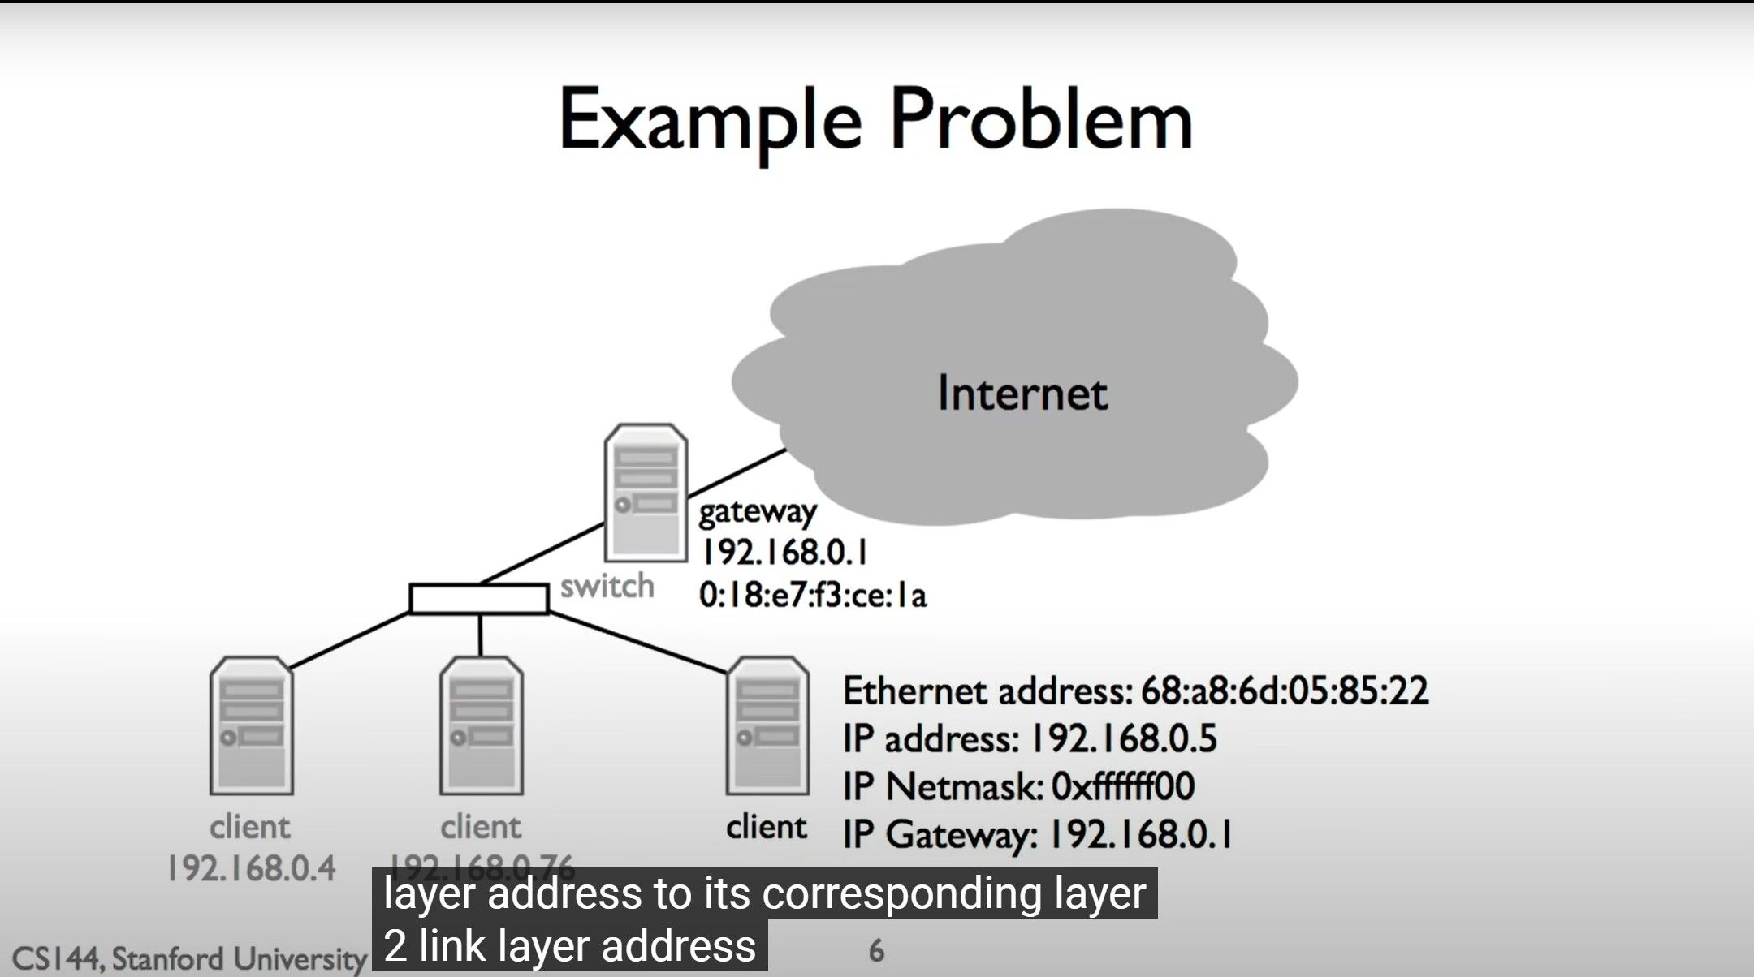

every node keeps a cache of mappings from ip addresses on it network to link layer addresses

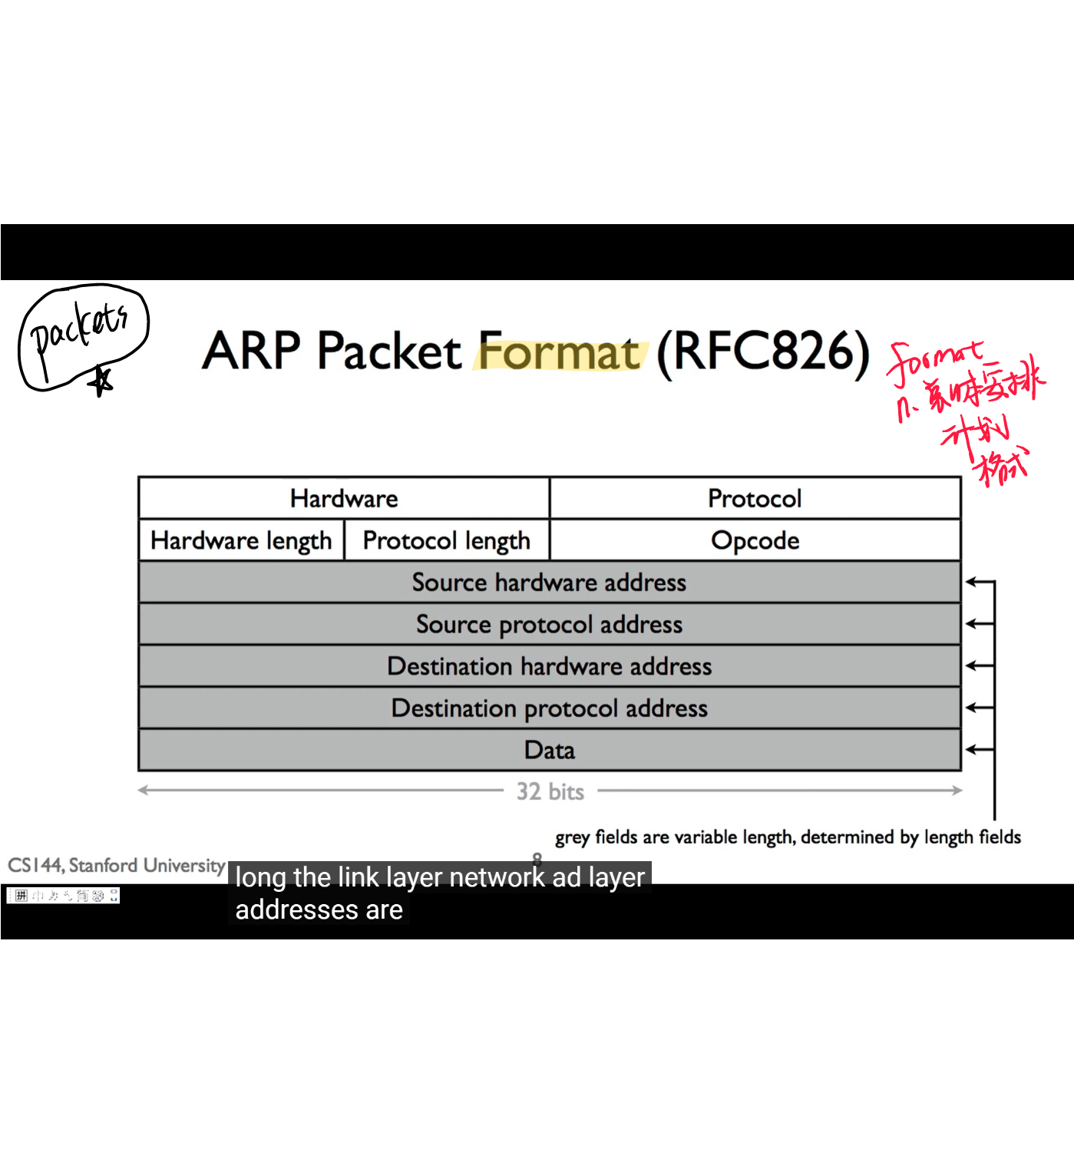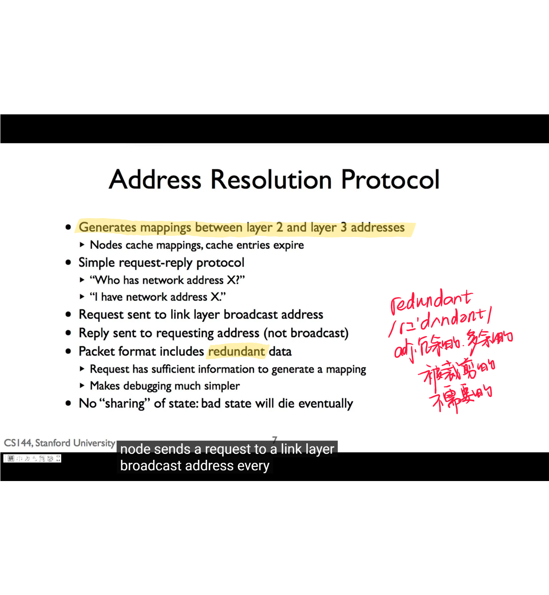

The Address Resolution Protocol is important for changing the high-level protocol address （ IP addresses)to physical network addresses

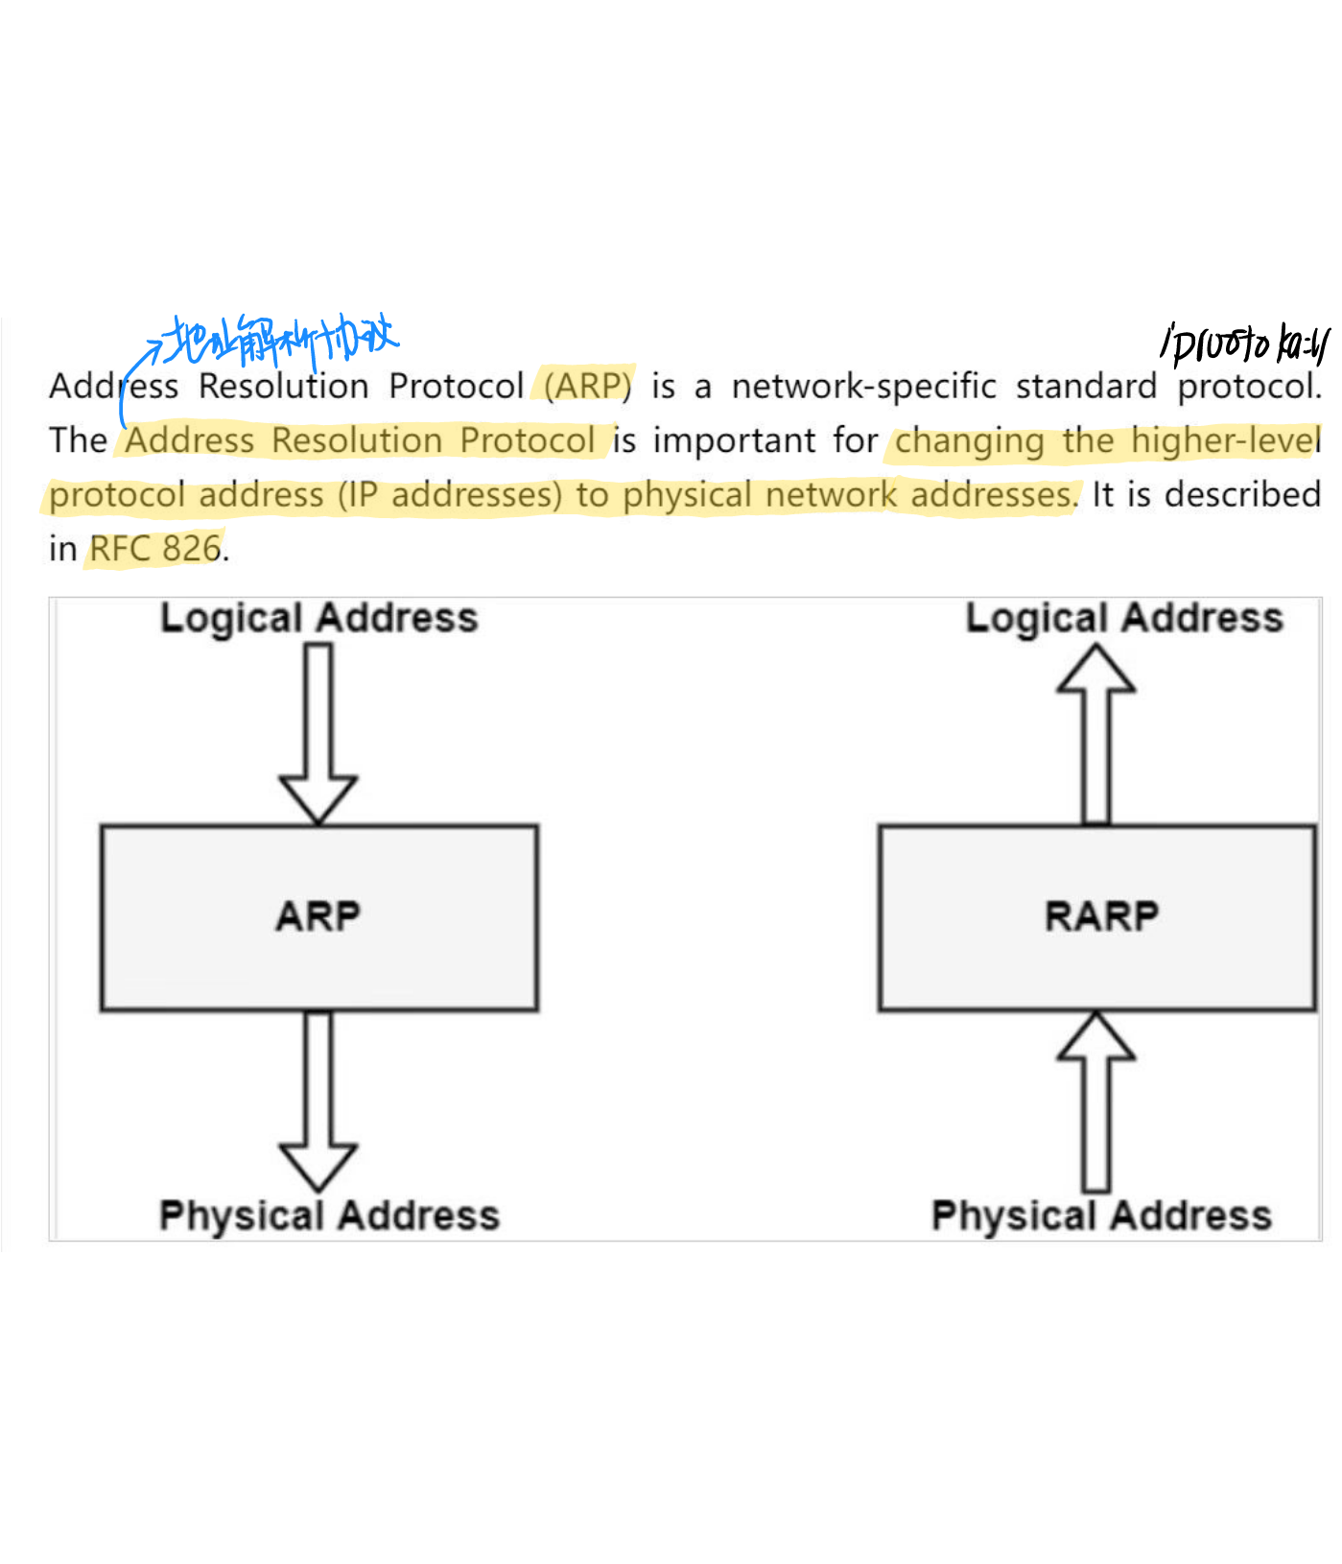

链路上每个设备都由一个物理地址标识，该地址通常打印在网络接口卡上（网卡）（NIC）

